Name : vaibhav kamal

**Exercise of Linux**

1. Create a directory "exercise" inside your home directory and create nested(dir1/dir2/dir3) directory structure inside "exercise" with single command.
   1. mkdir -p exercise/dir1/dir2/dir3

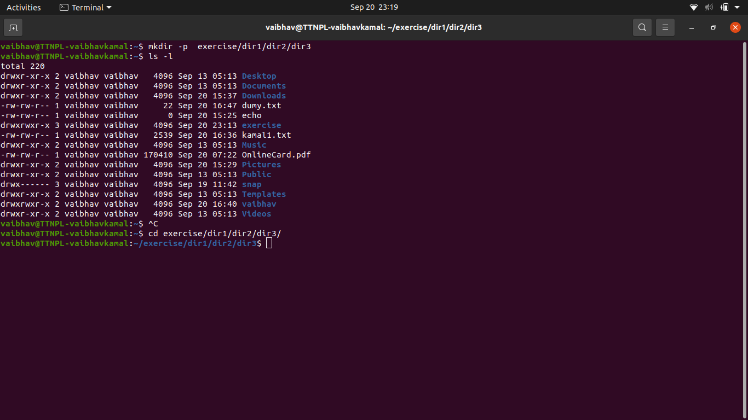

1. Create two empty files inside dir2 directory: emptyFile1,emptyFile2 in single command
   1. touch emptyFile1.txt emptyFile2.txt

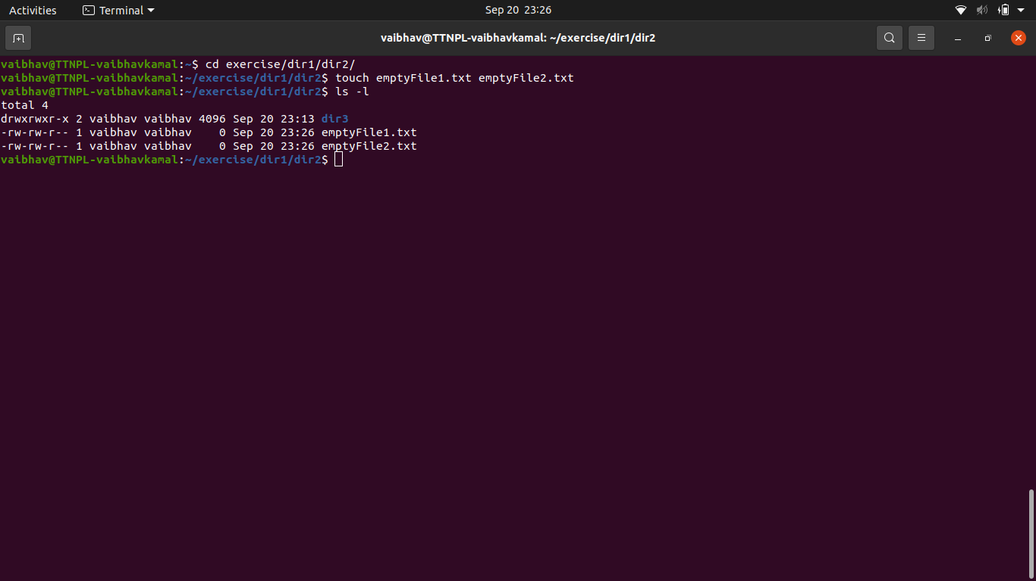

1. Create one file file1.txt containing text "hello world" and save it.
   1. echo "hello world" > file1.txt

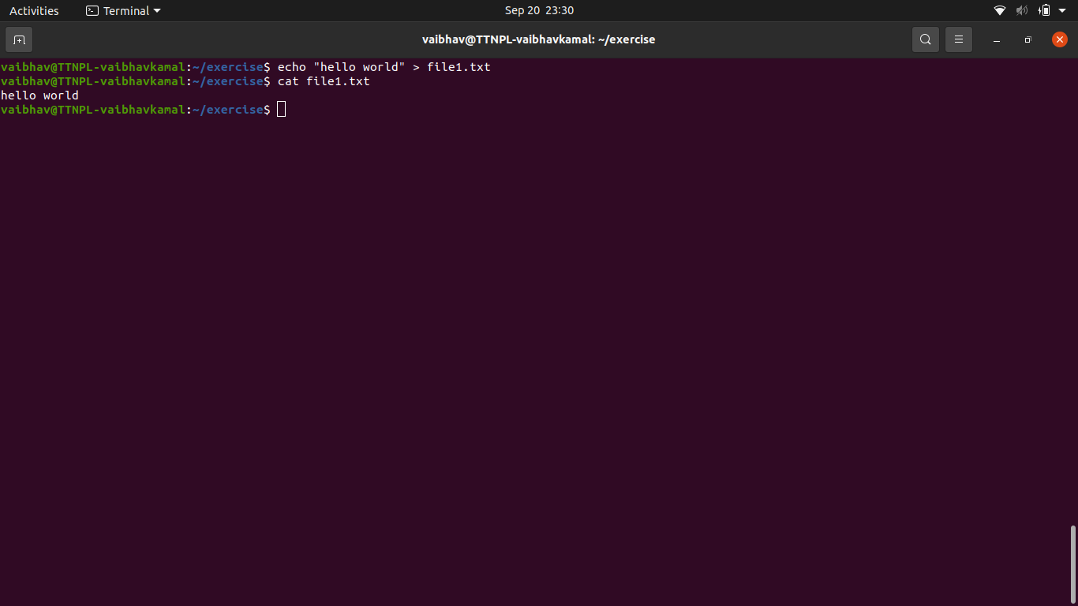

1. Find a "passwd" file using find command inside /etc. copy this files as passwd_copy and then rename this file as passwd_backup.
   1. sudo find /etc -type f -iname "passwd"
   2. cp /etc/passwd /home/vaibhav/exercise/passwd_copy
   3. mv passwd_copy passwd_backup

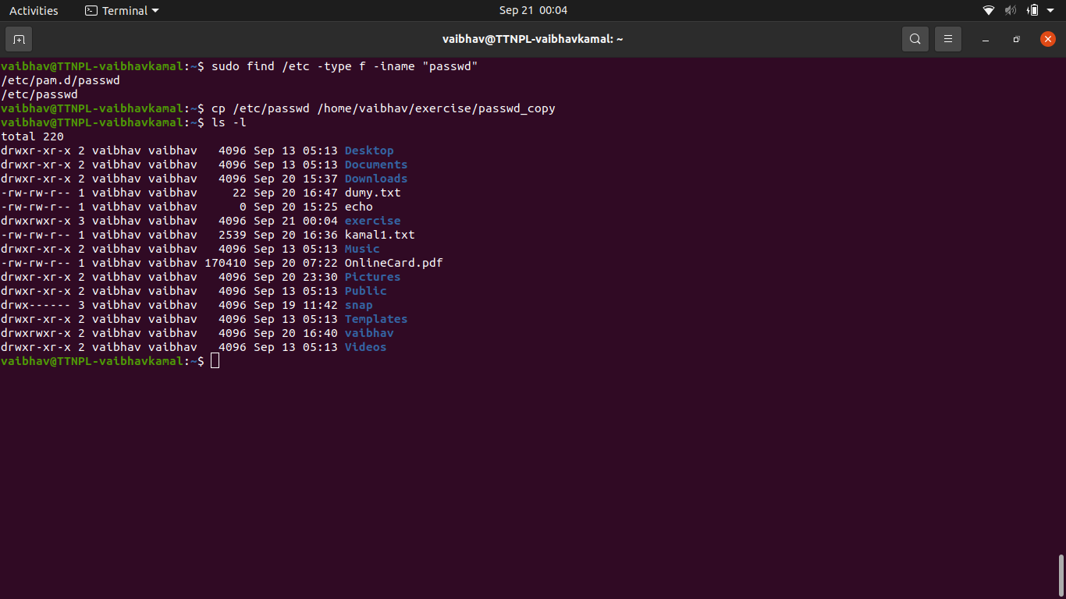

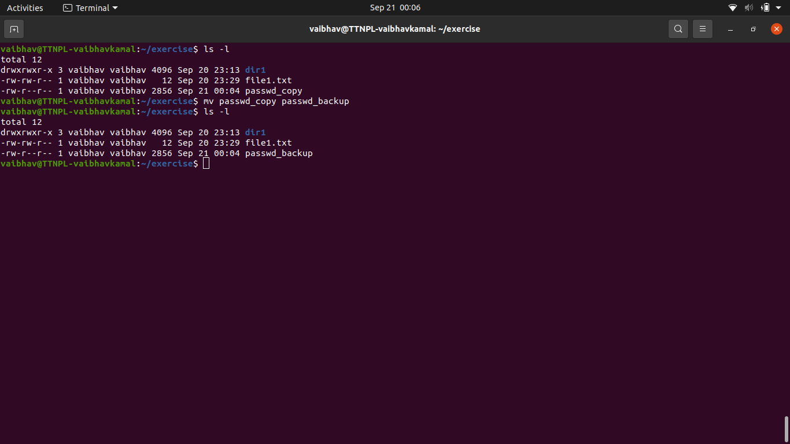

1. Try reading passwd_backup file in multiple tools: less,more,cat,strings etc and find the difference in their usage.
   1. Less = page by page access, less load time

less passwd_backup

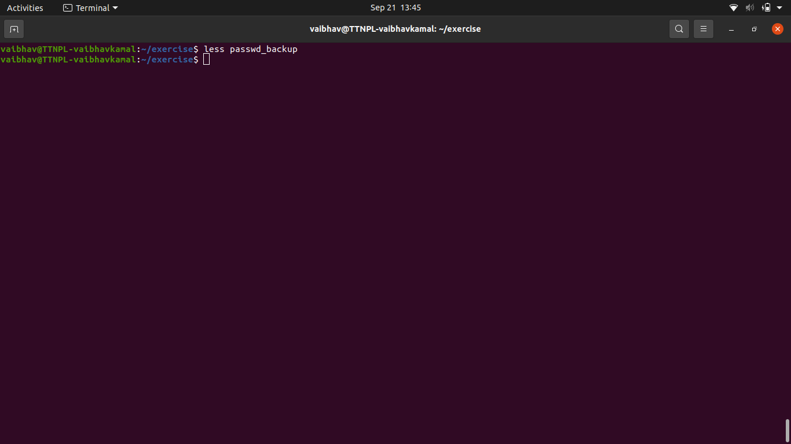

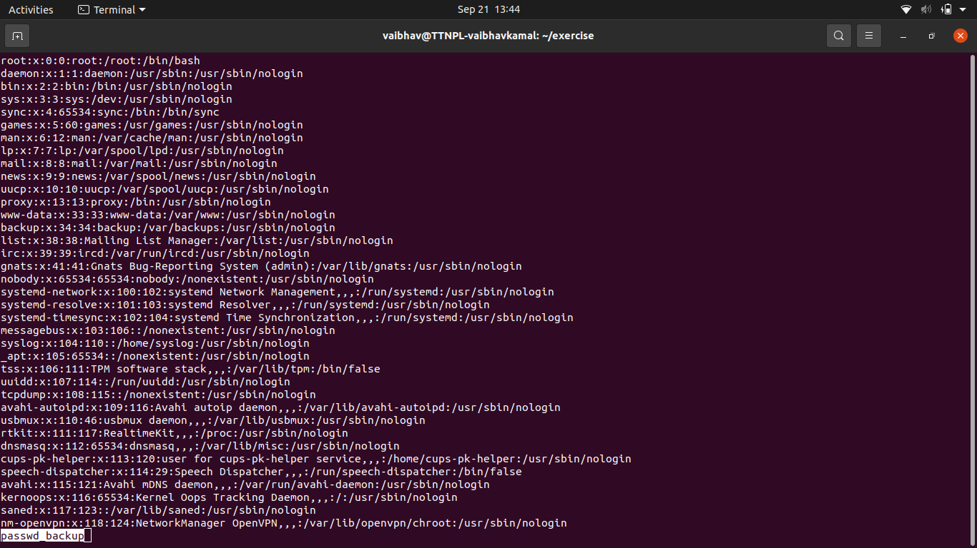

* 1. More = view all files at onces as a single file

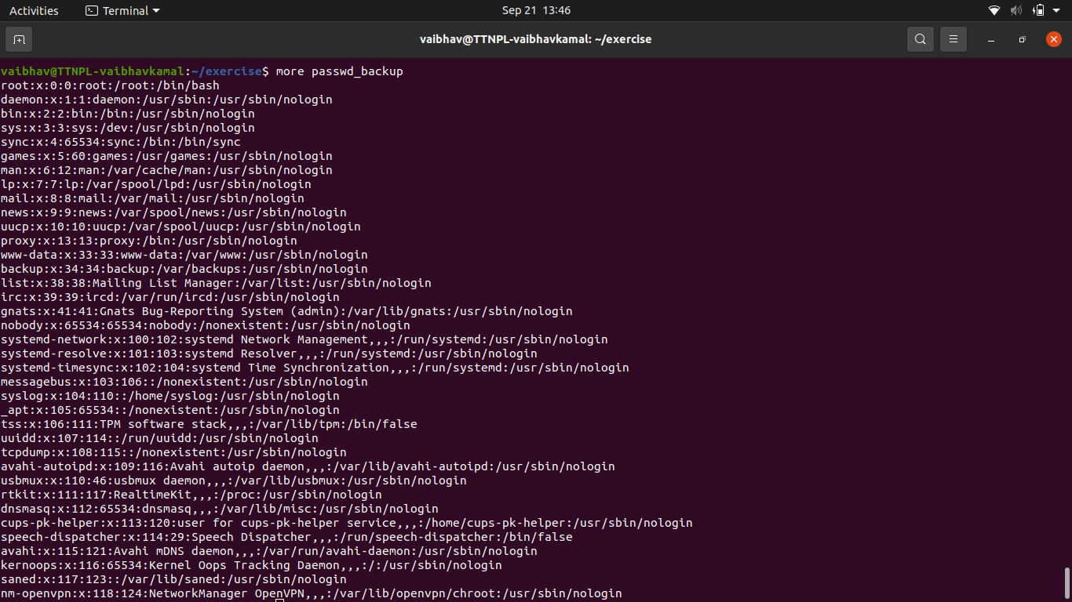

* 1. Tac = reverse output

tac passwd_backup

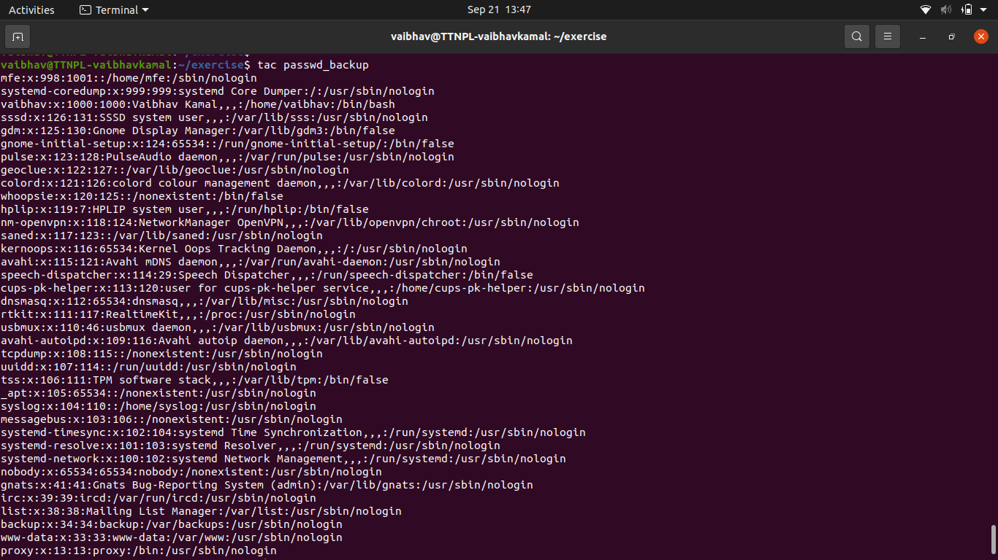

* 1. Cat = display output

cat passwd_backup

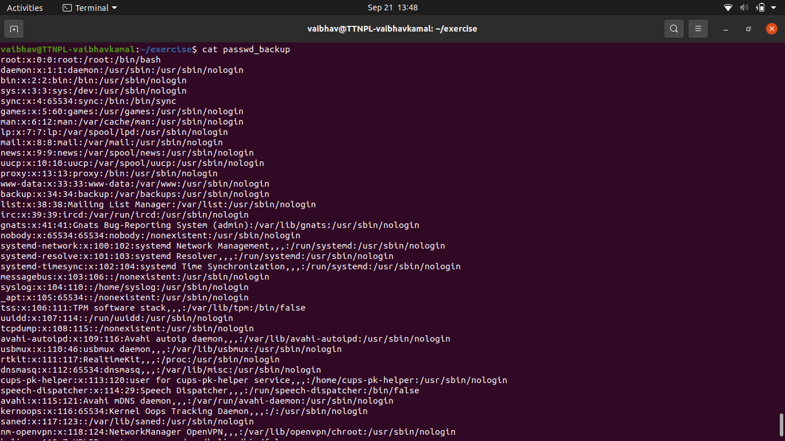

1. Find out the number of line in password_backup containing "/bin/false".
   1. grep "/bin/false" passwd_backup | wc

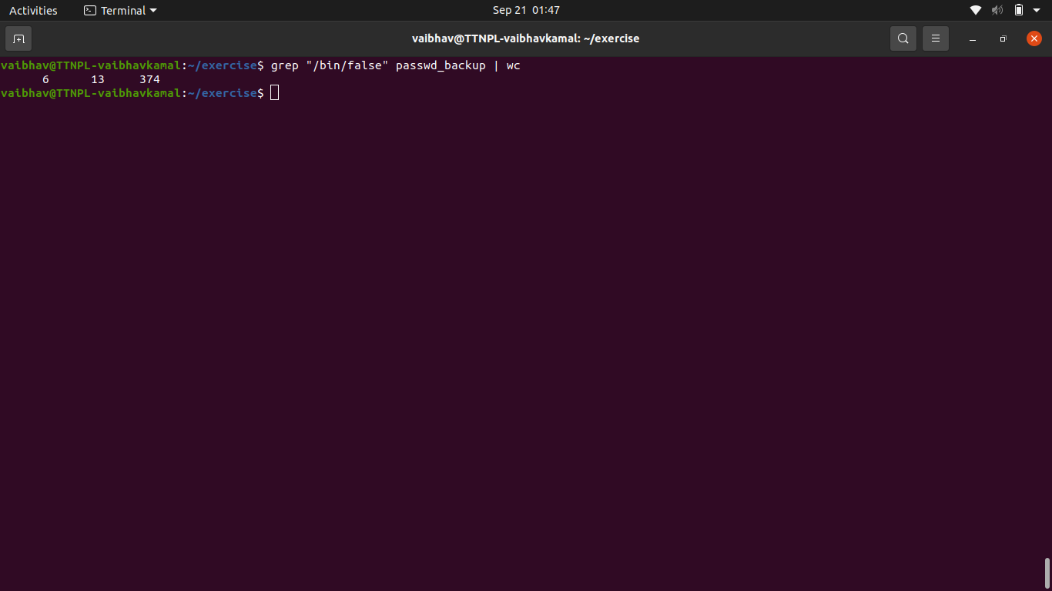

1. Get the first 5 lines of a file “password_backup” and Redirect the output of the above commands into file "output".
   1. head -n 5 passwd_backup > output.txt

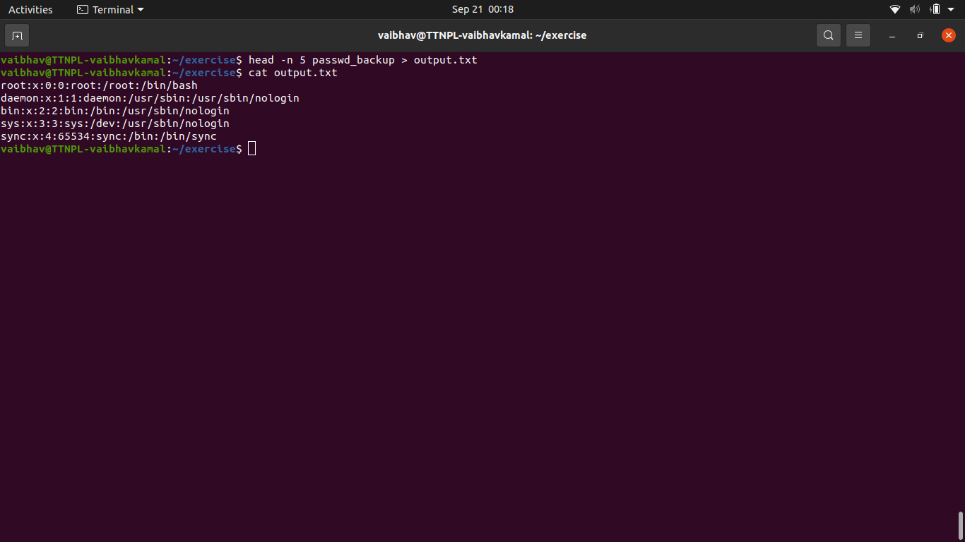

1. Create a "test" user,create its password and find out its uid and gid.
   1. useradd -m test
   2. passwd test

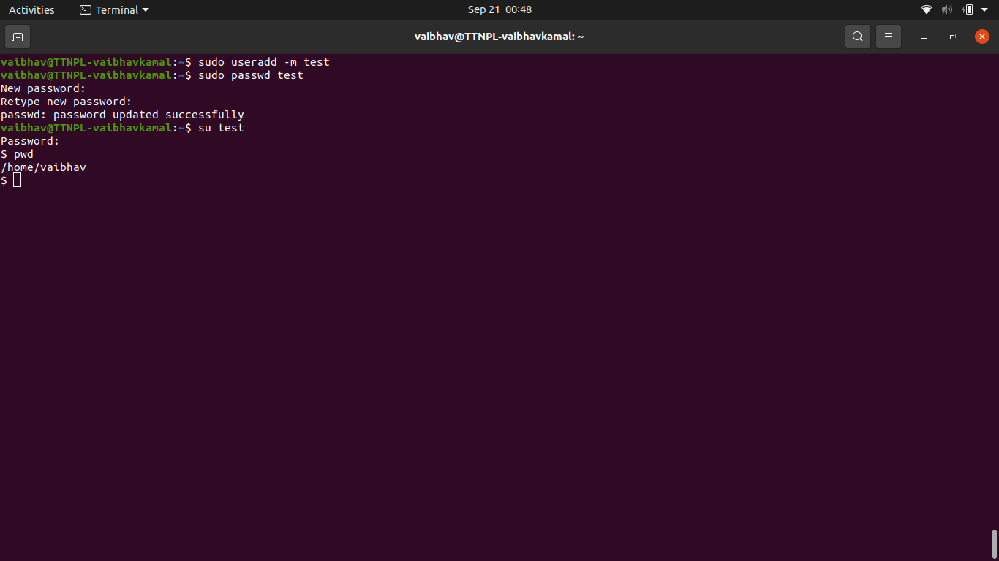

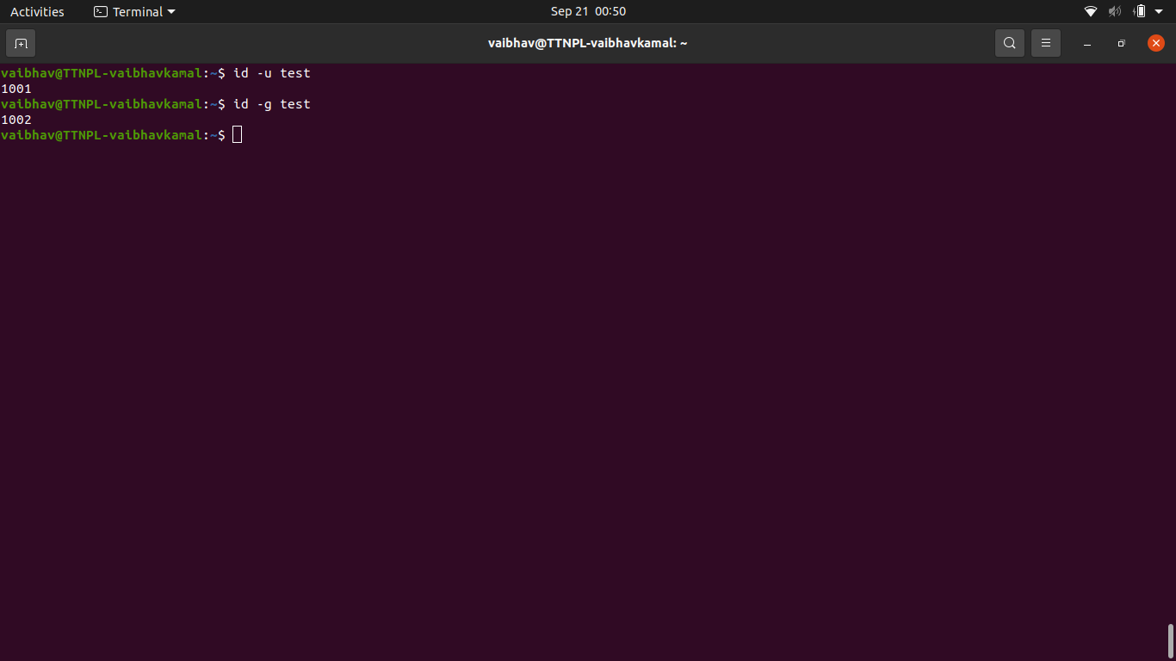

1. Change the timestamp of emptyFile1,emptyFile2 which are exist in dir2
   1. 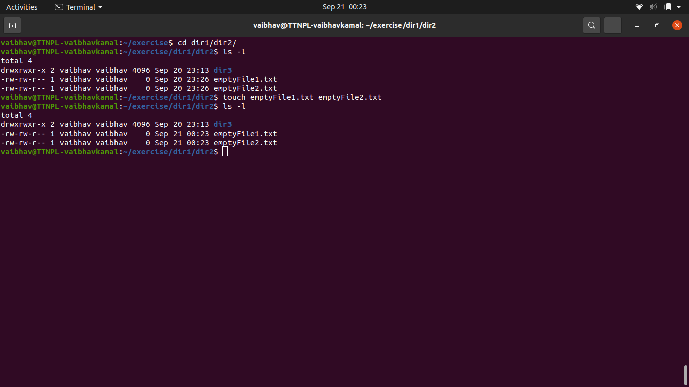

1. Login as test user and edit the "output" file created above. Since the permission wont allow you to save the changes. Configure such that test user can edit it.  
   1. Add group owner of the "output" file as the secondary group of testuser and check/change the "output" file permission if it is editable by group. Once done revert the changes
   2. Make the file editable to the world so that test user can access it. Revert the changes after verification
   3. Change the ownership to edit the file.
2. Create alias with your name so that it creates a file as "/tmp/aliastesting".
   1. alias vaibhav="mkdir -p /tmp/aliastesting.txt"
   2. 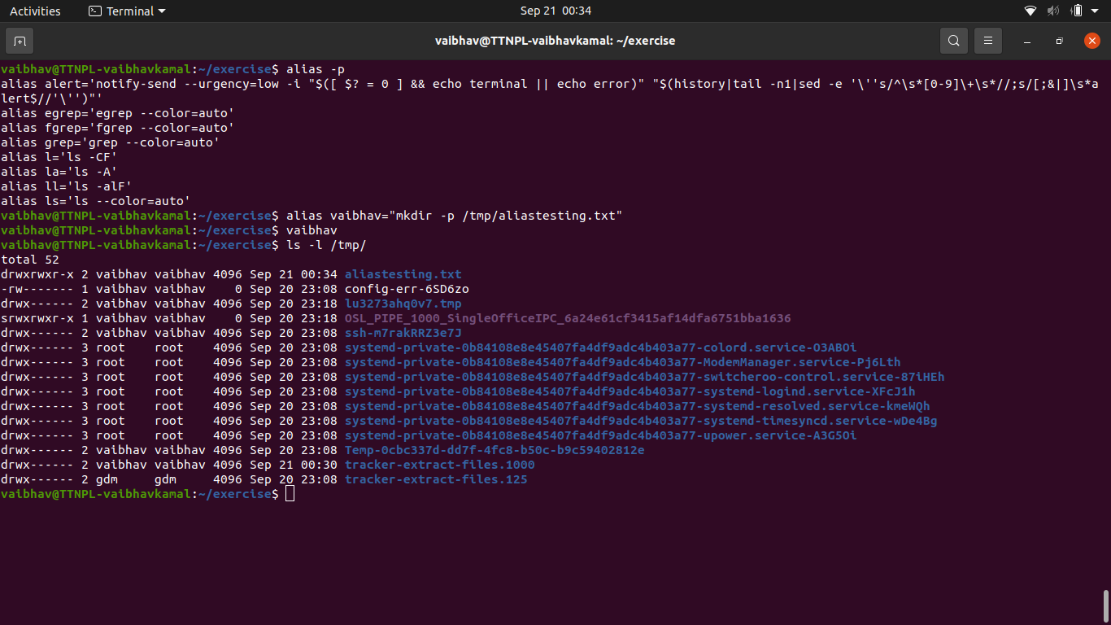

1. Edit ~/.bashrc file such that when you change to "test" user it should clear the screen and print "Welcome".
   1. 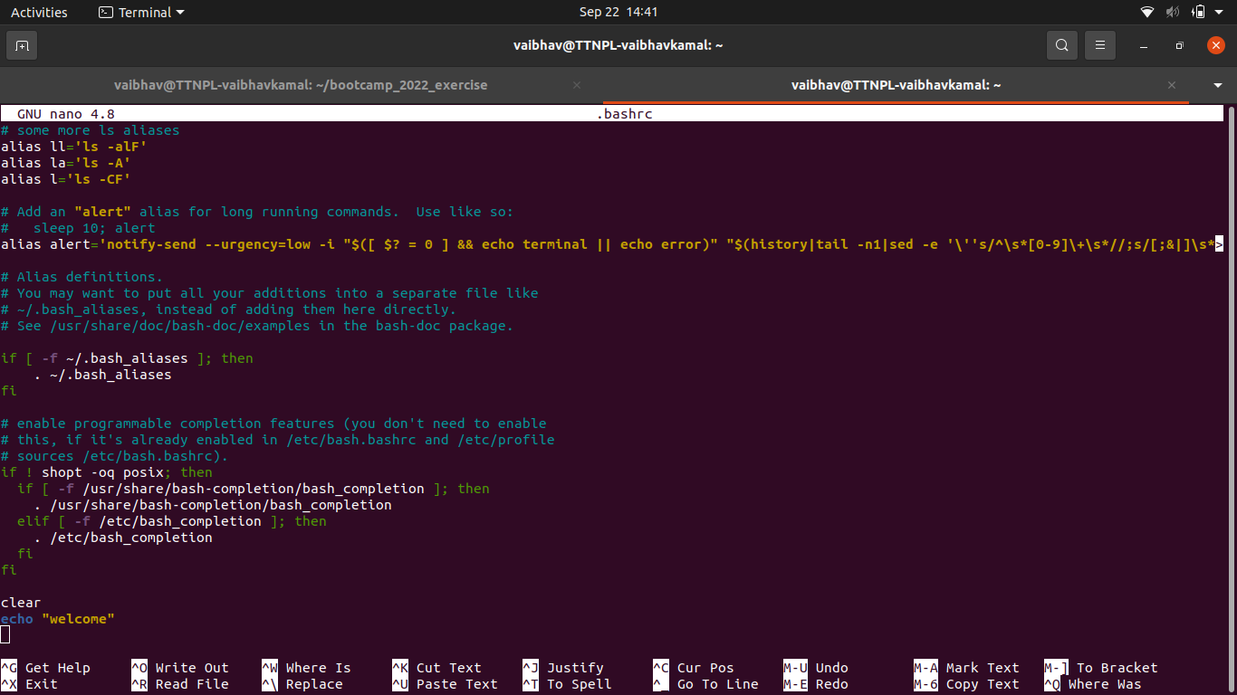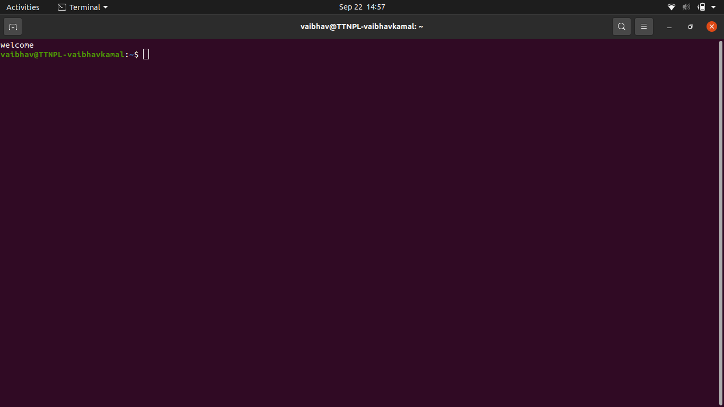
2. Install “zip” package.
   1. sudo apt install zip

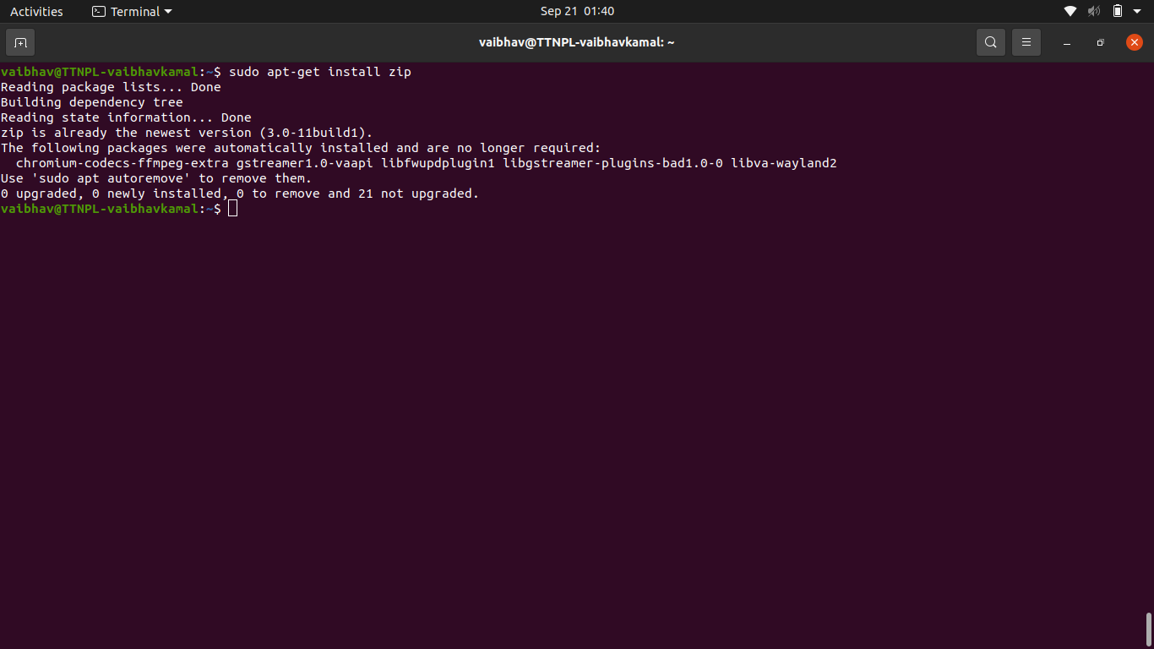

1. Compress "output" and "password_backup" files into a tar ball. List the files present inside the tar created.
   1. tar -cvf zip_file output.txt passwd_backup
   2. tar -tvf zip_file
   3. 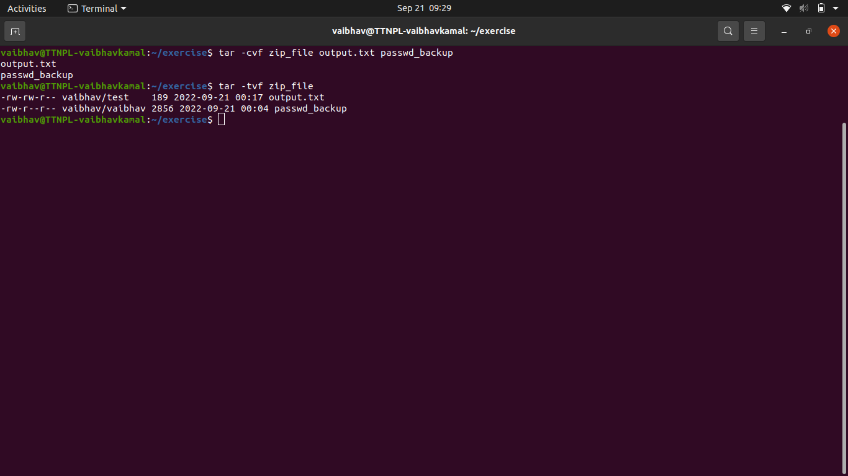
2. scp this file to test user
   1. sudo scp /home/vaibbhav/exercise/zip_file /home/test
   2. 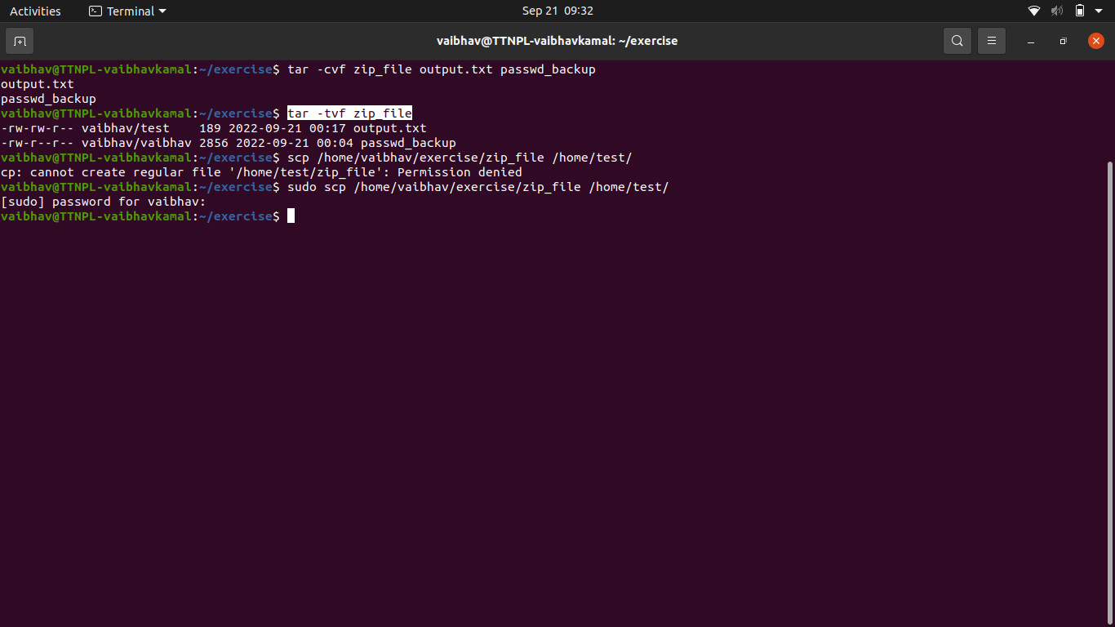
3. Unzip this tar file by logging into the remote server
4. Download any image from web and move to desktop
   1. sudo wget --output-document=/Desktop/hanuman_ji.jpg https://i.pinimg.com/736x/11/a0/5f/11a05f6d4f69747118edd5a52399d67b.jpg
   2. sudo mv hanuman_ji.jpg /Desktop/

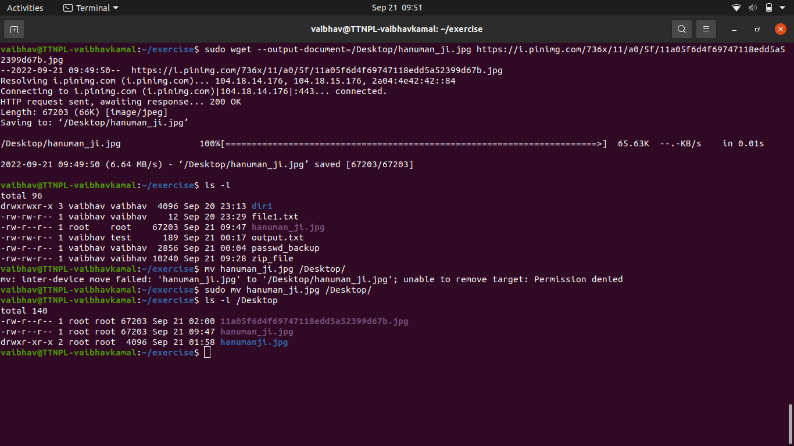

1. How to get help of commands usages.
   1. cat –help

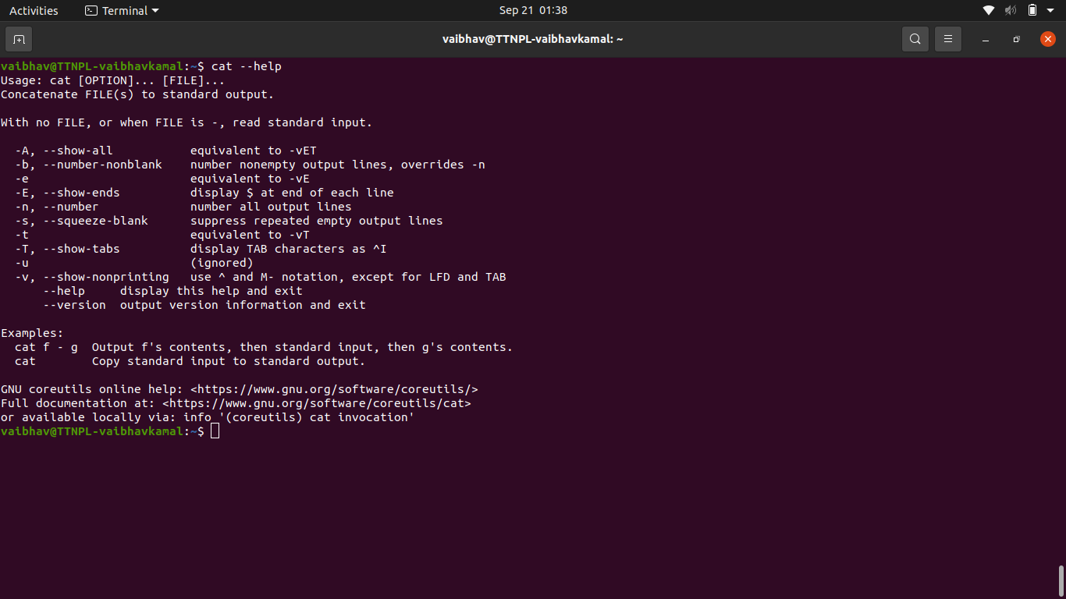

1. Create a symlink of /etc/services into /tmp/ports-info
   1. ln -s /etc/services /tmp/ports-info

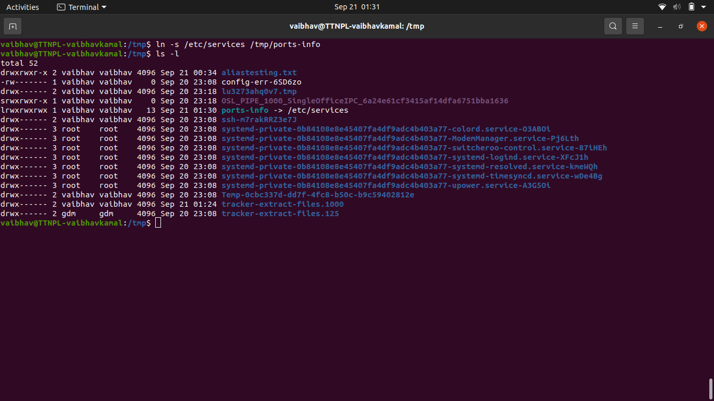

1. You are appointed as a Software/DevOps Engineer in ABC media services. On your first day you need to troubleshoot a problem. There is a command “xyz” somewhere installed in that linux system. But as a new joinee you do not have any idea about where is that Installed. How can you check that?
   1. whereis ls  
       